**Defense of the Mineral Fine Structure of the**

**American Lobster Cuticle**

Joseph G Kunkel§, Wolfram Nagelξ and Michael J Jercinovicγ

§ University of Massachusetts Amherst, Biology Department.

ξ Ludwig-Maximillian University, Munich, Physiology Institute.

γ University of Massachusetts Amherst, Geoscience Department.

Email: [joe@bio.umass.edu](mailto:joe@bio.umass.edu)

**Abstract:** The integument of a metazoan separates critical internal organs from the external environment, protecting organisms from microbes. Calcite and amorphous calcium carbonate are the most abundant minerals in lobster cuticle; they are the most vulnerable of minerals to acid and thus require protection from an acidified environment. Here we show that calcite acts in neutralizing an acidifying environment and this neutralizing function is modulated in this role by the epicuticle. Another more minor cuticle mineral component is carbonate apatite. Based on its location and form, lobster bone is proposed to play critical roles in the integument’s protective function. Carbonate apatite of lobster exhibited a flexible composition, its least soluble forms protecting the environmentally most exposed structures, dermal gland- and neuronal-canals. A trabecular-like carbonate-apatite structure similar to spongy bone illustrates efficient use of phosphate and likely provides the hardness exhibited in the phenolicly-crosslinked inner exocuticle region. We introduce a schematic model of the cuticle emphasizing regional diversity. A thin outer calcite layer provides a dense microbial barrier that dissolves slowly through the epicuticle, providing an external alkaline unstirred layer inhibitory to bacterial movement and metabolism. We show that injury to the epicuticle covering this mineral cuticle surface unleashed a strong flush of alkalinity providing a further general immune response accentuating the normal alkalinity of the antimicrobial unstirred layer. The mineral fine structure of lobster cuticle is described from the perspective of its structural protective role and antimicrobial function.

**Keywords:** *Homarus americanus*, calcite, carbonate-apatite, bone, electron microprobe, ion flux, Scanning Ion Electrode Technique SIET, unstirred-layer

**Running Title:** Calcite and Apatite in Lobster Cuticle

**Introduction**

The arthropod cuticle is a classic object of study by paleontologists, morphologists, cytologists, physiologists, and biochemists (Dennell 1947; Richards 1951; Roer & Dillaman 1984; Willis 1999; Locke 2001; Havemann et al. 2008). More recently, materials scientists have viewed crustacean cuticle as an example of a time tested natural composite material (Raabe et al. 2005). The organic polymer nature of the layered cuticle has been described as a twisted plywood pattern (Bouligand 1972, 1986). The mineral contribution to this composite has not been as well elaborated but this detail is now yielding to micro-chemical and physical measurements (Hild et al. 2009; Seidl 2011). It is clear that crustaceans combine minerals with organic polymers in their exoskeleton to create an effective durable protective covering for a taxonomic group that has survived hundreds of millions of years in salt and fresh water as well as land. However, the fresh water and ocean environments in which these composite materials need to function has recently changed relatively rapidly on an evolutionary time scale due to anthropogenic pressures (Turley et al. 2007; Ries et al. 2009) and we need to evaluate the properties of these vital skeletal organs in the light of those changes and extrapolate to the future. In order to do this extrapolation we need a model of how the cuticle is designed. Modeling from a structural engineering point of view, Nikolov and coworkers (2010) have computed general cuticular properties by a hierarchical averaging method. This averaging of properties hides the importance of unique properties of regional specializations. Our approach is to focus rather on the importance of diversity of regional properties with the surface properties being most important in a defense against external microbial attack.

Decapods (shrimp, lobsters and crabs) go through numerous molting cycles during their life that require regular wholesale replacement of the polymers and minerals of their exoskeleton. While early larval and juvenile molting cycles occur frequently enough (a few to several molts per year) to allow replacement of worn and damaged cuticle, later mid- and later-life molting cycles of the lobster must provide enduring protection for one to several years. The minerals in the decapod cuticle have traditionally been associated with the hardness and physical strength of the cuticle as if that structural property were their major role. Clearly the hardness of the decapod cuticle defends them against physical attack by major predators during the long intermolt period (REFERENCE?). It is possible that the minerals also independently participate in a chemically based defense against microorganisms.

The major mineral of the lobster cuticle is calcium carbonate that appears as calcite and amorphous calcium carbonate (Becker, et al. 2005). Calcite is most often discussed with respect to the strength of the lobster cuticle (Bouligand, 2004) despite the fact that calcite is a relatively soft mineral (3 on the MOHs scale of hardness). Nacre in mollusks is a well-known example in which enhanced properties of a composite product are achieved despite the relative softness of the mineral part (REFERENCE). Magnesium as a minor constituent is known as a hardening factor for crustacean calcite and fluoride for apatite structures (Mirtchi et al. 1991). Classic (Richards 1951) to modern investigators have reported small fractions of phosphatic mineral as components of crustacean cuticle, including carbonate-hydroxylapatite (REFERENCES TO MODERN INVESTIGATORS). A general role for phosphatic minerals in the crustacean cuticle has not been established and it has been somewhat ignored due to its reported relative minor compositional percentage (Lowenstam 1981; Bobelmann et al. 2007). The phosphatic mineral, carbonate-apatite, has been identified in the mineralized plates of a particular barnacle, *Ibla* (Whyte 1988; Lowenstam & Weiner 1992), a crustacean with more distinctly hardened structures in its integument. Other barnacles however are reported not to use this method of hardening. We here establish the distribution of multiple mineral forms of carbonate-apatite in the lobster cuticle.

Diseases affecting the cuticular structure of the American lobster, *Homarus americanus* H. Milne-Edwards, 1837, could provide clues to how a composite design is vulnerable and how the vulnerabilities might be attacked and defended. We are proposing a model of mineralized American lobster cuticle using arguments for how the cuticle defends its owner against chemical and microbial attacks such as seen in lobster impoundment (Smolowitz et al. 1992) and epizootic shell disease (Hsu & Smolowitz 2003). It has been hypothesized that shell disease in lobsters is initiated by vulnerabilities in the cuticle that are exploited by microorganisms, leading to progression to small circular lesions, which enlarge and coalesce into lesions that can cover the entire animals cuticle (Tlusty et al. 2007). Based on the appearance of microlesions of the cuticle, we propose that a microbial attack on the mineral component of the cuticle begins from the outside and continues using secretion of acid to dissolve the cuticular minerals until the organic layers are exposed enough for proteolytic and chitinolytic enzymes to be brought to bear to form microscopic and then macroscopic lesions characteristic of ESD. A model of the lobster cuticle may help identify these vulnerabilities and determine the role of changing environmental conditions on the initiation and progression of ESD

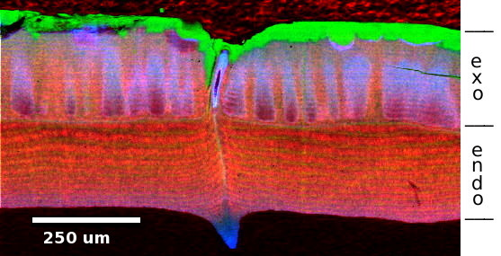

Figure 3. Intermolt cuticle cross-section parallel to canal path viewed via EMP of Ca (green), P (blue) and Cl (red) content. A thin calcite layer is green. Purple canal wall has Ca/P of 4; blue nipple has Ca/P of 3.5 and exocuticle trabeculae have Ca/P of 7.

**Material and Methods**

Lobsters were obtained from several locations. Lobsters with signs of impoundment shell disease were obtained May 2008 from the Maine State Aquarium at Booth Bay Harbor. Lobsters with (Fig. 1A) and without signs of epizootic shell disease were obtained in 2004 from trawls by the NOAA Ship Albatross IV at the mouth of Narragansett Bay as well as in canyons at the edge of the continental shelf directly south of Narragansett Bay. Lobsters from locations outside the known range of ESD and no clinical signs were obtained June 2007 or 2008 from the State of Maine Ventless Trap Program from Casco Bay to Isle of Shoals. An equal number of lobsters with and without signs of ESD were obtained in 2008 and 2009 from Narragansett Bay above the Pell Bridge. Lobsters obtained in Maine were maintained until used in running 15˚C fresh seawater at the University of New England Marine Science Center or in recirculating 15˚C artificial seawater at UMass Amherst. RI lobsters were maintained until use in recirculating 15˚C artificial seawater at UMass Amherst. Lobsters were fed during workdays with frozen scallop muscle ad lib for a period of ½ hour. Uneaten scallop was removed. Shells of the Atlantic Jacknife Razor Clam, *Ensis directus* Conrad, 1843, were obtained from Pinepoint Beach, Scarborough ME shortly before use.

To evaluate the role of mineralization in the cuticle’s defenses we treated the cuticle as a moist geological specimen (Kunkel et al. 2005b). Excised small cuticle squares were plunge frozen in liquid nitrogen cooled propane; then the frozen water was substituted with acetone, and the pieces were slowly brought to room temperature. The cuticle was embedded in Epo-Thin Resin (Buehler). The plastic-embedded cuticle specimen was ground and polished with graded carborundum and diamond abrasive (METADI® SUPREME 6 - 0.25 µm) suspended in polishing oil on TRIDENT™ polishing cloths to prevent movement of any water soluble components (Kunkel et al. 2005b). The specimens were examined in a Cameca Ultrachron Electron Microprobe or in a Cameca SX-50 Electron Microprobe.

Ionic flux from the cuticle was measured using the Scanning Ion Selective Electrode Technique (SIET) (Kunkel et al. 2005a). To measure flux emanating *in situ* from living cuticle, a form-fit tygon observational arena was glued to the cephalothorax of lobsters using Krazy-Glue® Gel (Fig. 2A). A Teflon nut was also glued to the cephalothorax to provide a basis for attaching a stereotactic holding device to maintain the lobster immobile enabling electrodes to be brought within 100 um of the cuticle surface for flux measurements (Fig. 2B). A minimal-artificial-seawater was formulated which included only the ions Na, K, Cl, Ca and Mg in close to normal amounts compared to natural sea water, or selectively reduced experimentally, that served as the medium for measuring ionic flux to and from the cuticle surface. Both the lobster holding chamber and the measuring chamber buffer were continuously cooled to 15˚C using a purpose-built Peltier cooling system. Measurements of flux simultaneously with two SIET electrodes, Ca and H, held in a Dual Probe Holder (Biomedizinische Geräte, Germering, Germany) were made under ASET software (ScienceWares, Falmouth, MA) control using dual SIET amplifiers and motion controls electronics (Applicable Electronics, Forestdale, MA).

Artificial lesions of lobster and mollusk shells were created with a Microlux® Variable Speed Drill Press (MicroMark) with a digital depth finder (Fig. 1).

**Results**

The intermolt cuticle of a lobster without signs of shell disease (INDICATE IF THIS LOBSTER IS FROM WITHIN OR OUTSIDE THE RANGE OF ESD) we observed: 1) A dense thin birefringent crystalline calcite layer on the outside (Fig. 3); 2) a carbonate-apatite lining of dermal gland and neurite canals (Figs. 4,5); and 3) trabecular carbonate-apatite used in the exocuticle providing hardness (Fig. 4 A,B). These three features are derived from electron probe microanalysis (EPMA) compositions of intermolt lobster cuticle (Fig. 4 and 5) illustrating different aspects of calcium and phosphorous mineral distribution in the exo-cuticle of the intermolt lobster. A dermal gland canal which has a canal lining of relatively high P:Ca ratio typical of canals close to the surface of the cuticle is seen in Fig. 4A. A cross-section of a canal illustrates a dermal gland canal which has two regions of distinct P:Ca ratios, an outer luminal layer P:Ca is 2 while the cuticle sided P:Ca is 3.51 (Fig. 5). The calcite vs bone signals are differentiated by Principal Components (PC) analysis of the composition variation among pixels. PC-1 points to calcite variation while PC-2 identifies two levels of carbonate apatite seen as blue and green in the fig 5C’s PC-2 panel. The two ratios of P:Ca are also seen as distinct slopes of Ca:P pixels with ratios of 2 vs 3.51 in fig 5D. Both of these ratios represent typical bone ratios of P:Ca as seen in Table 1. A P:Ca of 2 represents bone with a composition Ca10(PO4)5(CO3)(OH)3 • H2O , one of the highest phosphate contents exhibited by bone.

We find that the outermost mineral surface of the lobster intermolt cuticle consists mainly of a smooth dense layer of calcite (Fig. 4A), that has a calcium Kα intensity close to mollusk (clam) shell, which is 95-98% CaCO3 (Fig. 5D). This birefringent outer layer of calcite appears continuous but it punctuated at regular but widely spread over-disperse intervals by cuticular organules (Fig. 6), a term popularized by Lawrence (Lawrence1966, Merritt 2006) for small organs such as dermal glands and bristles, which are formed from single epidermal mother cell dividing to form a small groups of cells, the organule. The cuticle of the lobster was studded with organules of simple dermal glands and interspersed with compound organules that combine sensory bristles with accompanying dermal glands as surface structures and accompanying clustered carbonate-apatite lined canals (Fig. 6). During the molting process cuticular organules are moved apart from each other during the generally isometric expansion of the cuticle surface. The expansion of the cuticle in lobsters varies but is approximately 1.1 fold increase in linear dimensions which represents a 21% increase in cuticle area. New organules need to develop and be inserted into the widening expanses of cuticle devoid of organules. We observed a progression of development from the simple to the compound organule, fig 6, that is compatible with similar development seen in insects (Merritt, 2006).

A single organule canal or bristle cell secretes a canal cuticle surrounding a narrow canal which allows environmental outlet for secretion from an organule gland cell or forms a protective sheeth about neurites innervating sensory organules such as mechano- or chemo-sensory bristles at the surface of the cuticle as seen in fig 4A. The canal lumen in the bristle or gland canal is available to the outside environment and could represent a path of attack by microbes. In all arthropods these canal passages are for carrying secretions or protecting sensory neurites traveling through the cuticle. This canal has been shown in other arthropods to be lined with an epicuticle similar in structure to the general cuticle's epicuticle (Kunkel 1975). The lobster cuticle canals' 10-20 um openings lead into 400-1000 um long canals in the lobster cuticle into which bacteria could invade and form colonies that could build up substantial populations and establish significant acid gradients, potentially damaging to a calcium carbonate based cuticle. How are the two surfaces, surface cuticle and canal lining, protected from microbial attack in the lobster?

This crystalline calcite layer can be observed in polarized light as a uniformly birefringent layer which can turn corners, indicating its controlled orientation, fig 3 arrows, most likely deposited along polymer fibrils or bundles. Consistent with this, the numerous pore canal filaments represent microvillar extensions of the epidermal cells course through the physiologically living endo- and exo-cuticle but are excluded from the calcite layer seen in unshared AFM figures. The remnant spaces, formerly occupied by live filaments, are surrounded by organic and mineral layering observed with EPMA and by AFM but essentially end at the inner surface of the calcite layer. The crystalline density, seen in figs 4 and 5, of the calcite layer does not afford a spatial avenue for bacterial attack unless the density is first compromised. The calcite layer extends down along the canal exterior at the organule canal intersection, seen in cross-section in fig 4A and in tangential section in fig 4B and 5A, leaving a relatively small space between it and the carbonate-apatite canals, fig 5A. The calcite layer and its boundary with the apatite tubes might allow access into the cuticle by microbes down to the typical size of a bacterium (0.2-2 µm) and we may need to know the tolerances of this space under stress as predicted by our model. The flat surface of the general cuticle surface does not encourage the buildup of a pH gradient from a bacterial colony growing on an open surface. This is because protons in water as hydronium ions have an anomalous 12-times faster diffusion than their diameter predicts (Kunkel et al. 2001). This is a physical reason that a calcite surface is a sufficient material to create a physical barrier to microbial attack … protons created by a group of bacteria will disperse rapidly and not accumulate enough titer to do damage to the calcite. The calcite layer of the cuticle is also covered by a waxy epicuticle that is an efficient protection from bacterial attack for another reason: during the slow solubilization of calcite through the epicuticle into the ocean water, carbonate and Ca ions are released. The carbonate takes a proton from water becoming bicarbonate and releasing a hydroxyl and thus results in a more basic zone layer in the unstirred layer (Pohl et al. 1998) adjacent to the cuticle. The unstirred layer gradient properties are a result of the speed with which diffusion of an ion establishes a nearby high pH gradient despite competing bulk flow of nearby liquid that eventually undoubtedly will affect the gradient depletion. The high pH gradient is dispersed as it merges with the bulk of the adjacent seawater but a thin alkaline aqueous surface unstirred layer remains on any calcitic shell as an antibiotic to bacterial growth and attack (Palmer 1997; Bombelli & Wright 2006). However, calcite would not be an effective material choice as a lining to the cuticular organule canals because in the enclosed small diameter, but extended length, of a gland or neurite canal, proton gradients could be established by bacteria that could easily dissolve a calcite lining. Rather, the organule’s canal is fortuitously lined by a phosphatic mineral of moderate high density that is more acid resistant. Chemical analysis of this layer by EPMA demonstrates, figs 4, 5, that in Ca:P ratio it conforms to the flexible composition of CAP, which is similar to bone, Table 1 (Wopenka & Pasteris 2005), being resistant to acid solubilization. The only other calcium phosphate that could theoretically apply is tetracalcium phosphate, a mineral not described in living tissues (Dorozhkin & Epple 2002). Either would provide the ratio of Ca:P of approximately 2 which is observed in some neurite- and gland-canal walls. But, interestingly, carbonate-apatite as seen in vertebrate bone exhibits a more generally accepted formulation, Table 1, that has a more flexible Ca:P ratio that can include 2:1, 2.25:1, 2.67:1, 3.5:1, 4:1 and 7:1 which are all relatively discretely observed (figs 4, 5) in canal tubes with broad compositional ratios as predicted by the bone formula. The discreteness of the carbonate-apatite formulations is often emphasized by finding two Ca:P ratios in a single cross-section, fig 5A,D. Carbonate-apatite as a mineral is substantially more acid resistant than calcite or amorphous-calcium carbonate. Carbonate apatite had been identified as a minor component in X-ray diffraction powder patterns of lobster cuticle (Boßelmann et al. 2007) as well as being a major constituent of the *Ibla* barnacle valve plates. However the importance of carbonate-apatite in Decapod cuticles has been minimized. The role of carbonate-apatite as a lining of the gland and neurite canals of lobster cuticle could be a major selective advantage in this crustacean's resistance to microbial attack via the canal lining. In the lobster the most exposed canal linings are closer to 2:1 Ca:P in carbonate-apatite composition which make it least sensitive to acid attack (Baig et al. 1999).

The composition of the calcite, inner-exocuticle and endocuticle layers were studied in greater detail using 12 quantitative transects of lobster intermolt cuticle using the SX-50 electron microprobe. Care was taken to include transects through trabecular as well as non-trabecular regions of the cuticle which changed the chemical profiles mainly in the inner-exocuticle which the trabeculae populate. With the SX-50 EMP we were able to measure the content of the other Group 2 Alkaline Earth Metals (Mg, Ca, Sr, Mn, Ba) (Fig. 7). Of particular note is the precipitous decline in Mg, Sr, Mn and Ba together in the calcite layer toward the surface of the cuticle. This may represent a clue to the role of the minor divalent ions in the calcite layer function.

The two distinctly different forms of shell disease, impoundment shell disease and epizootic shell disease, attack at different points of the cuticle, impoundment disease attacks at the dermal gland canals and epizootic shell disease on the plane between dermal gland canals. This difference of point of attack allows us to create alternative hypotheses about the progression of shell disease based on predictable vulnerabilities of a model. In pursuit of this theory we describe how our cuticle model, fig 8, might provide a protective role using a major component, the minerals, and then use the model's explicit mineral properties to suggest hypothetical modes of attack. Our morphological mineral model based on some key exemplar physical evidence, e.g. figs 3-5, suggest a protective rationale and a structural role for key minerals of the lobster cuticle that may have provided a selective force during its structural evolution.

The potential vulnerable aspects of the dermal glands are derived from inspecting our model of the lobster cuticle. First, the phosphatic wall of the canal needs to tightly interface with the cuticle's calcite layer, fig 3A,B. There is a visible space between the two mineral structures seen particularly in fig 5B that is filled with the anion chloride. These Cl filled spaces around canals are also seen as red in fig 4B. What are the acceptable tolerances of these spaces? There is a possibility of a failure in the phosphate or carbonate chemistry for this juncture particularly in the crowded and altered water quality of lobster pounds and rearing facilities after which the disease is named. There is ample evidence of the limiting nature of available phosphate in the North Atlantic arena (Wu et al. 2000; Zubkov et al. 2007). In the altered temperature, pH, salinity and microbial environment of a lobster pound or aquarium the chemistry could clearly be a source of problems. If the dermal gland and neurite canals phosphatic lining were thinner or incomplete for some reason, the ability of bacteria to access and attack the underlying chitin and protein linkages could be encouraged. In addition, an acidified seawater environment might allow a pH gradient produced by a bacterial colony to be more effective given a lower imposed diffusion gradient at the opening of the canals. These hypotheses can be pursued in a relatively simple marine life-table flow-through environment by adjusting the conditions that perhaps interact to allow the impoundment type shell disease to develop.

The study of epizootic shell disease with respect to our model is perhaps less straightforward. Efforts must be taken to avoid the conditions of impoundment shell disease from occurring. The evidence from light microscope sections of de-mineralized cuticle from early shell diseased lobsters suggests that the newest lesions develop in the calcite-plane region between the organules producing early pillars of relatively undigested cuticle. We suggest that these pillars are the remains of phosphatic trabeculae of the inner exocuticle, fig 4A, which should be more acid resistant. Our work with oxygen electrodes on artificial lesions of the cuticle suggest that until the thin dense calcite layer is compromised there is no response of oxygen utilization by the lesioned cuticle. Once the calcite layer is breached, the cuticular polyphenol oxidase is activated, oxygen starts being utilized and melanin accumulates at the lesion. Therefore the first hypothetical point of attack in epizootic shell disease would be an imperfect calcite layer. This might occur because the calcite layer was not properly developed during the time shortly after ecdysis, during the phase that the cuticle provisionally hardens or it could result from the attack of this layer after it had been formed imperfectly.

Our application of SIET to study the flux of ions from the cuticle and early stage lesions was frustrated by very few examples of early lesions to which we could apply our measurement of Ca- and proton-flux. However from the few such lobsters, fig 2A being one, it was evident that there was a slow flux outward of Ca2+ and inward of H+ from asymptomatic lobster cuticle and a substantial increase of that flux over lesions. This observation immediately rejected our earlier naive hypothesis that we should detect early latent- or developing-lesions from the secretion of protons by a microbial film or colony at the site of a future lesion. Ionic flux from the lobster cuticle weather asymptomatic or symptomatic of shell disease is dominated by the calcium carbonate content of the cuticle. The entire surface of the lobster carapace is slowly leaching CaCO3 from the superficial calcite layer.

More productive information was obtained by our creation of graded artificial lesions such as seen in fig 1B. Such lesions allowed us to examine numerous lobsters with different degrees of lesion reaching various levels in the cuticle. These lesions were examined using dual Ca- and H-LIX microelectrodes simultaneously at essentially the same location. The pattern was highly reproducible. The Ca-flux was the mirror opposite of the H-flux. Ca2+ appeared to exit the lesion and H+ appeared to enter the lesion. This is explained in our model by the reaction:

CaCO3 + H2O = Ca2+ + HCO3- + OH-

The dissolution of CaCO3 reaction produces Ca2+ and OH-, and we measure the outward diffusing Ca2+ and OH- as outward diffusing Ca2+ and inward diffusing H+. This opposite behavior of Ca-flux and H-flux is a signature of dissolving calcite or aragonite or amorphous calcium carbonate.

When the calcite layer is penetrated by an artificial lesion a stronger flux of Ca and H is measured because the dissolution of amorphous calcium carbonate has a lower energy requirement and thus it dissolves more quickly. The design of a calcite layer underlain by an amorphous calcium carbonate layer can be seen as selectively advantageous in fighting a progressive shell disease lesion.

Broadening our understanding of this phenomenon we see in the lobster, we have studied mollusk calcite shells that are covered by a protective periostracum, a protein polymer layer laid down and sometimes maintained by the mollusk mantle tissue. This periostracum is analogous to the epicuticle of the lobster in that it protects the calcite layer from rapid dissolution. We observed that the artificial lesions created in the mollusk periostracal covering release a stream of Ca2+ and OH- ions similar to those we have observed emanating from our lobster artificial lesions (Fig. 9).

**Discussion**

The most interesting discovery that was made during our fine structure study of the lobster cuticle minerals was the identification of a variety of forms of carbonate apatite in the lobster’s cuticle architecture. In the bone pipes that form the protective tubes for dermal glands and neurites, there are often two distinct carbonate apatite formulae applied to discrete adjacent layers in the tube. The rule so far observed is that the outermost bone layer has the highest Ca:P ratio. Since the tube is most likely produced by the single specialized cell of the organule cluster, it is likely that the outer (cuticle-side) layer of the tube is laid down later as the cell regresses from the cuticle surface and more inner layers of the cuticle are being laid down. This may represent a natural reduction in the available phosphorous as the organism starts growth and cell division that require phosphorous for nucleic acid and protein synthesis (references?).

While our lobster cuticle model, fig 8, is derived from earlier observations from various research groups including our own (PROVIDE REFERENCES), it relies heavily on the novel hypothesis that the cuticle minerals function chemically to protect against environmental attacks by microorganisms. Our structural model is of intermolt cuticle and we expect it to provide a basis for understanding the relatively long-term resistance to disease experienced by the lobster during its extended intermolt. The cuticle’s natural immune properties are also testimony to the difficulty that experimentalists have had in transmitting shell disease between symptomatic lobsters and asymptomatic aquarium mates during the intermolt period.

The model, based on EMP measurements, polarized light microscopy, and ionic flux studies has an outer crystalline calcite layer covering a trabecular calcium phosphatic exocuticle layer with intervening amorphous calcium carbonate between the trabeculae (Fig. 8). The spongy-bone-like trabecular structure brings up the question of what cuticular feature is responsible for the slow progressive hardening of lobster carapace cuticle as described by Waddy and coworkers (1995). Based on our mineralization maps and our model and the hardness tests of Raabe and associates (Raabe et al. 2005) it seems that the hardness would not coincide with the outer calcite density. In their progressive indentation tests the outermost layer, corresponding to the calcite layer in thickness, is a moderately soft outer layer. That layer would need to be established relatively quickly for self-protective reasons based on our model. The slower, development-of-hardness layer would correspond to the zone of the phosphatic trabeculae, i.e. the inner exocuticle, which would develop more slowly depending on available phosphorous. Living in a phosphorous poor environment (Wu et al. 2000, Zubkov et al. 2007) the lobster may have developed a strategy of using its limited phosphorous availability by slowing down the cuticle hardening process as we know it (Waddy et al. 1995).

The lobster trabeculae are possibly convergent with the trabeculae of vertebrate spongy bone in ways beyond chemical structure. The dynamics of development of the lobster trabeculae may well be based on stress. The dorsal carapace is the site of many thoracic muscle attachments and the stress provided by those attachments could result in the massive hardness that develops at the dorsal lateral carapace *vs.* the thinner lateral ventral carapace sides that cover the branchial cavity. This stress model of lobster bone development may also apply to the thickness of cuticle chelae which could be behaviorally adjusted by how the lobster uses its crusher vs cutter chelae.

Amorphous calcium carbonate is found between trabeculae of the exocuticle perhaps associated with chitin and protein fibrils as demonstrated in a marine isopod (Seidl et al. 2011); this inherently soft mineral form is similar in electron density to the amorphous calcium carbonate found in the endocuticle that is measureably the softest layer of the lobster cuticle based on Raabe and associates (2005) measurements. This amorphous calcium carbonate may be an essential reserve of available calcium carbonate that can provide the calcium for trabecular development and also respond to cuticular injury by dissolving to form a flush of alkalinity that is an antimicrobial shield in the cuticle. Exocuticle composed of pure carbonate-apatite would first be a waste of scarce phosphate but also would not serve as a ready source of antimicrobial alkalinity.

Cuticle mineralization in Decapods for Ca2+ and CO32- is acknowledged to be accomplished from the epidermal side of the cuticle after ecdysis (Compere et al. 1993; Wheatly 1999). It requires an investment of energy since the source of CO32- in the cuticle is bicarbonate in the hemolymph that requires a proton to be exported into the hemolymph as a carbonate reaches the cuticle, fig 8. Our model of the intermolt lobster cuticle would be compatible with the calcification process in expecting creation of the calcite layer early after ecdysis, which would establish microbial invulnerability of the surface soon after the calcite layer was made continuous. The energy by which the lobster expels a proton into the hemolymph is the investment in deposition of calcite which becomes the investment in the integrity of the cuticle. Our model also provides a separate imperative for enough phosphate to be invested (1) as organule tubes protecting secretion and neuro-sensory communication and (2) as phosphatic trabeculae to be associated with the well-described (Waddy et al. 1995) gradual hardening of the lobster cuticle that occurs after ecdysis. The hardness of the inner exocuticle based on proper development of the phosphatic trabeculae would provide a more rigid base that would prevent potential brittle failure of the calcite layer due to flexing. This separates the antimicrobial function of the calcite layer from the physical hardness established by the phosphatic trabeculae while allowing them to cooperate in the objective of providing an antimicrobial barrier. The structural and chemical information of this model provides predictions about how the cuticle minerals function during the intermolt period and the predictions can be used to develop hypotheses that will drive future research. For instance, our model predicts that a successful infection of the cuticle could be pioneered by more alkali resistant strains of organisms. Furthermore, the antimicrobial function for calcium carbonate based integuments may play a general role in both arthropod and mollusk shellfish that has not been previously appreciated. The role in carbonate conservation by the epicuticle and periostracum of shells may have as important a role in marine arthropods and mollusks as water-conservation by the epicuticle of the integument has for terrestrial arthropods (Beament 1961, Moore & Francis, 1985).

Last but not least, the rational structure of the lobster cuticle carbonate-apatite structures allow it to serve as a stepwise model for bone synthesis in a non-vertebrate system which might make it invaluable for insights into bone synthesis in general.

**Acknowledgements:** This work was supported by a seed grant from MIT SeaGrant, by the National Marine Fisheries Service as the “New England Lobster Research Initiative: Lobster Shell Disease” under NOAA grant NA06NMF4720100 to the University of Rhode Island Fisheries Center, and an NSF funded collaboration of Cameca and UMass Geosciences. The views expressed herein are those of the authors and do not necessarily reflect the views of NOAA or any of its sub‐agencies. The US Government is authorized to produce and distribute reprints for government purposes, notwithstanding any copyright notation that may appear hereon.

**References**

Baig, A. A., J. L. Fox, R. A. Young, Z. Wang, J. Hsu. 1999. Relationships Among Carbonated Apatite Solubility, Crystallite Size, and Microstrain Parameters. Calcif. Tissue Int. 64:437-449.

Beament, J. W. L. (1961) The Water Relations of insect cuticle. Biological Reviews 36: 281–320.

Becker, A., A. Ziegler, M. Epple. 2005. The mineral phase in the cuticles of two species of Crustacea consists of magnesium calcite, amorphous calcium carbonate, and amorphous calcium phosphate. Dalton Transactions 10:1814–1820.

Bombelli, E. C. & E. R. Wright. 2006. Efecto del bicarbonato de potasio sobre la calidad del tomate y acción sobre *Botrytis cinerea* en postcosecha (in Spanish). Cienc Invas Agric 33:197-203.

Bobelmann, F., P. Romano, H. Fabritius, D. Raabe, M. Epple. 2007. The composition of the exoskeleton of two crustacea: The American lobster *Homarus americanus* and the edible crab Cancer pagurus Thermochimica Acta 463:65-68.

Bouligand, Y. 1972. Twisted fibrous arrangements in biological materials and cholesteric mesophases. Tissue Cell 4:189-217.

Bouligand, Y. 1986. Theory of microtomy artefacts in arthropod cuticle. Tissue Cell 18:621-643.

Bouligand, Y. 2004. The renewal of ideas about biomineralisations. C R Palevol 3:617-628.

Buckeridge, J. S., W. A. Newman. 2006. A revision of the Iblidae and the stalked barnacles (Crustacea: Cirripedia: Thoracica), including new ordinal, familial and generic taxa, and two new species from New Zealand and Tasmanian waters Zootaxa 1136:1-38.

Compere, P., J. A. Morgan, G. Goffinet. 1993. Ultrastructural location of calcium and magnesium during mineralization of the cuticle of the shore crab, as determined by the K-pyroantimonate method and X-ray microanalysis. Cell Tissue Res 274:567-577.

Dennell, R. 1947. The occurrence and significance of phenolic hardening in the newly formed cuticle of Crustacea Decapoda. Proc. Roy. Soc. Lond. Ser. B 134:485-503.

Dorozhkin, S. V., M. Epple. 2002. Biological and medical significance of calcium phosphates. Angew. Chem. Int. Ed. 41:3130-3146.

Havemann, J., U. Müller, J. Berger, H. Schwarz, M. Gerberding, B. Moussian. 2008. Cuticle differentiation in the embryo of the amphipod crustacean *Parhyale hawaiensis*. Cell Tissue Res 332:359-370.

Hild, S., F. Neues, N. Znidarsic, J. Strus, M. Epple, O. Marti & A. Ziegler. 2009. Ultrastructure and mineral distribution in the tergal cuticle of the terrestrial isopod *Titanethes albus*. Adaptations to a karst cave biotope. J. Struct. Biol. 168:426-436.

Hsu, A. C., R. M. Smolowitz. 2003. Scanning electron microscopy investigation of epizootic lobster shell disease in *Homarus americanus*. Biol. Bull. 205:228-230.

Kunkel, J. G. 1975. Cockroach Molting. I. Temporal organization of events during molting cycle Blattella germanica (L.). Biol. Bull. 148:259-273.

Kunkel, J.G., S. Cordeiro, Y.(J.) Xu, A. M. Shipley & J. A. Feijo. (2005a) The use of non-invasive ion-selective microelectrode techniques for the study of plant development. In: Plant Electrophysiology- Theory and Methods ed. by A. G Volkov, Springer-Verlag, Berlin/Heidelberg, pp 109-137.

Kunkel J. G., M. J. Jercinovic, D. A. Callaham, R. Smolowitz, M. Tlusty. (2005b) Electron Microprobe Measurement of Mineralization of American lobster, *Homarus americanus*, Cuticle: Proof of concept. 2005 Lobster Shell Disease Workshop, UMass Boston. New England Aquarium. Aquatic Forum Series, pp 76-82.

Kunkel J. G., L.-Y. Lin, Y. Xu, A. M. M. Prado, J. A. Feijó, P. P. Hwang and P. K. Hepler. (2001). The strategic use of Good buffers to measure proton gradients about growing pollen tubes. In “Cell Biology of Plant and Fungal Tip Growth” (A Geitman, Ed.), pp. 14pp. IOS Press, Amsterdam.

Lawrence, P. A. 1966. Development and determination of hairs and bristles in the milkweed bug, *Oncopeltus fasciatus* (Lygaeidae, Hemiptera). J. Cell Science 1:475-498.

Locke, M. 2001. The Wigglesworth Lecture: Insects for studying fundamental problems in biology. J. Insect Physiol. 47:495-507.

Lowenstam, H. A. & S. Weiner. 1992. Phosphatic shell plate of the barnacle *Ibla* (Cirripedia): A bone-like structure. Proc. Natl. Acad. Sci. U.S.A. 89:10573-10577.

Lowenstam, H. A. 1981. Minerals formed by organisms. Science 211:1126-1131.

Martin, J. W., K. A. Crandall, D. L. Felder. 2009. Preface. In: Decapod Crustacean Phylogenetics, eds J. W. Martin, K. A.Crandall, D. L. Felder, CRC Press, pp. viii-xi.

Merritt, D. J. 2006. The Organule Concept of Insect Sense Organs: Sensory Transduction and Organule Evolution. Adv. Insect Physiol. 33: 192-241.

Mirtchi, A. A., J. Lemaître, E. Munting. 1991. Calcium phosphate cements: effect of fluorides on the setting and hardening of beta-tricalcium phosphate-dicalcium phosphate-calcite cements. Biomaterials 12:505-510.

Moore, P. G. and C. H. Francis. 1985. On the water relations and osmoregulation of the Beach-Hopper *Orchestia gammarellus* (Pallas) (Crustacea: amphipoda). Journal of Experimental Marine Biology and Ecology 94: 131-150.

Nikolov, S., M. Petrov, L. Lymperakis, M. Friák, C. Sachs, et al. 2010. Revealing the design principles of high-performance biological composites using ab initio and multiscale simulations: the example of lobster cuticle. Adv Mater 22 519-526.

Palmer, C. L., R. K. Horst, R. W. Langhans. 1997. Use of bicarbonates to inhibit in vitro colony growth of *Botrytis cinerea*. Plant Dis 81:1432-1438.

Pohl, P., S. M. Saparov, Y. N. Antonenko. 1998. The size of the unstirred layer as a function of the solute diffusion coefficient. Biophys J:75 1403-1409.

Raabe, D., C. Sachs, P. Romano. 2005. The crustacean exoskeleton as an example of a structurally and mechanically graded biological nanocomposite material. Acta Mater 53:4281-4292.

Richards, A. G. 1951. The Integument Of Arthopods, U. Minnesota Press, 411pp.

Ries, J. B., A. L. Cohen, D. C. McCorkle. 2009. Marine calcifiers exhibit mixed responses to CO2-induced ocean acidification. Geol Soc Am 37:1131-1134.

Roer, R. D. & R. M. Dillaman. 1984. The structure and calcification of the crustacean cuticle. Am. Zool. 24:893-909.

Seidl B, K. Huemer, F. Neues, S. Hild, M. Epple & A. Ziegler. 2011. Ultrastructure and mineral distribution in the tergite cuticle of the beach isopod *Tylos europaeus* Arcangeli, 1938. J. Struct. Biol. [Epub ahead of print].

Smolowitz, R. M., R.A. Bullis, D.A. Abt. 1992. Pathologic cuticular changes of winter impoundment shell disease preceding and during intermolt in the American lobster, *Homarus americanus*. Biol. Bull. 183:99-112.

Tlusty, M. F., R. M. Smolowitz, H. O. Halvorson, S. E. DeVito. 2007. Host susceptibility hypothesis for shell disease in American lobsters. Journal of Aquatic Animal Health 19:215-225.

Turley, C. M., J. M. Roberts, J. M. Guinotte. 2007. Corals in deep-water: will the unseen hand of ocean acidification destroy cold-water ecosystems? Coral Reefs 26:445-448

Vega, F. J., V. M. Dávila-Alcocer, H. F. Filkorn. 2005. Characterization of cuticle structure in Late Cretaceous and Early Tertiary Decapod Crustacea from Mexico. Bulletin of the Mizunami Fossil Museum 32:37-43.

Waddy, S. L., D. E. Aiken, D. P. V. deKleijn. 1995. Control of Growth and Reproduction. In: Biology of the Lobster *Homarus americanus*. Ed J. R. Factor, Academic Press, New York, pp 217-266.

Wheatly, M.G. 1999. Calcium homeostasis in crustacea: the evolving role of branchial, renal, digestive and hypodermal epithelia. J Exp Zool  283:620-640.

Whyte, M. A. 1988. The mineral composition of the valves and peduncle scales of *Ibla quadrivalvis* (Cuvier) (Cirripedia, Thoracica). Crustaceana 55:219-224.

Willis, J. H. 1999. Cuticular proteins in insects and crustaceans. Amer. Zool. 39:600-609

Wopenka, B., J.D. Pasteris. 2005. A mineralogical perspective on the apatite in bone. Materials Science and Engineering C 25:131-143.

Wu, J., W. Sunda, E.A. Boyle, D.M. Karl. 2000. Phosphate depletion in the western North Atlantic Ocean. Science 289:759-762.

Zubkov, M.V., I. Mary, E.M.S. Woodward, P.E. Warwick, B.M. Fuchs. 2007. Microbial control of phosphate in the nutrient-depleted North Atlantic subtropical gyre. Enviro. Microbiol. 9:2079-2089.

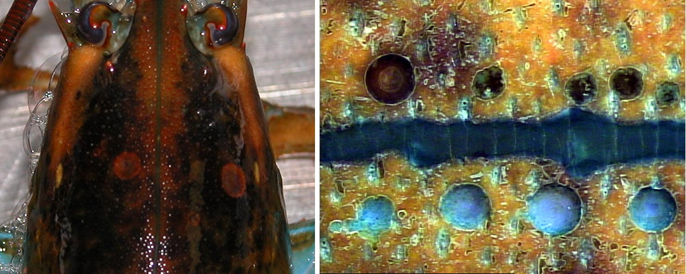

Figure 1. Natural and artificial lobster shell lesions. **A.** American lobster, *Homarus americanus*, with very mild epizootic shell disease lesions. Two circular lesions are indicated by arrows. **B.** Nine artificial lesions imposed on a live lobster carapace using a drill press serve as models of the lesion process. The flux of ions derived from the dissolving shell is followed measuring differential concentrations over short distances with the specific ion electrode technique (SIET). The lesions in B are separated by the mid dorsal suture. The 5 upper, more melanized, lesions were produced 1 month earlier than the bottom 4 lesions.

A B

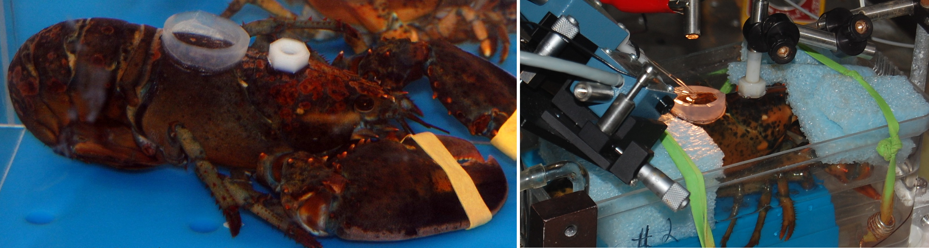

Figure 2. A lobster with a Tygon observation chamber enclosing carapace cuticle and a Teflon-nut glued to adjacent carapace. (**A)** The observation chamber encloses a region of cuticle with a lesion and holds a measured amount of minimal-ASW. This lobster is studied in (**B)** with dual SIET probes for proton and calcium flux. The large chamber in B holding the lobster is temperature regulated with Peltier cooled ASW that allows the lobster to be probed for hours and afterwards reserved to be probed on succeeding days. This way the progression of shell lesions can be followed over days or months. The objective is to extrapolate back to the origin of the lesion.

Figure 3. Birefringent **Calcite** of healthy lobster cuticle follows surface sculpturing. Top and bottom image are same view with analyzer rotated 90°. Arrows show complementary birefringence of calcite layer on 90° rotation of analyzer.

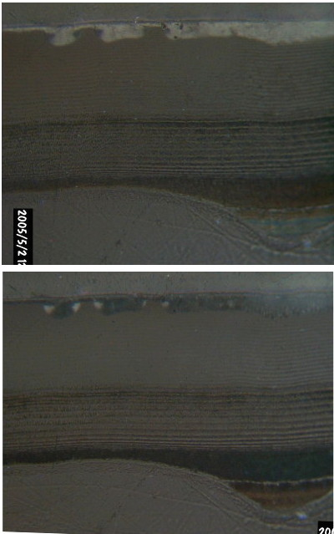

A



B

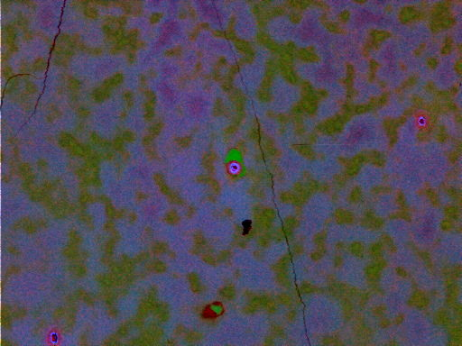

Figure 4. Lobster calcite and carbonate-apatite structures interpreted as false color from three EMP of Ca (green), P (blue) and Cl (red) content. **A.** Intermolt cuticle cross-section parallel to neurite canal path showing a Ca:P composition canal wall. A thin green calcite layer colored by Ca alone. A blue nipple area at the cuticle-epidermis interface has Ca:P of 3.5. The exocuticle trabeculae have Ca:P of 7. **B.** A tangentially polished section of intermolt exocuticle just under the calcite layer shows Ca (green) intrusions of calcite, P (blue) and Cl (red). Purplish trabeculae with Ca:P of 7 are separated by fields of amorphous calcium carbonate seen as greenish since it combines Ca with Cl. Deeper red areas indicate Cl rich spaces surrounding the dermal and neurite canals from the background cuticle layers.

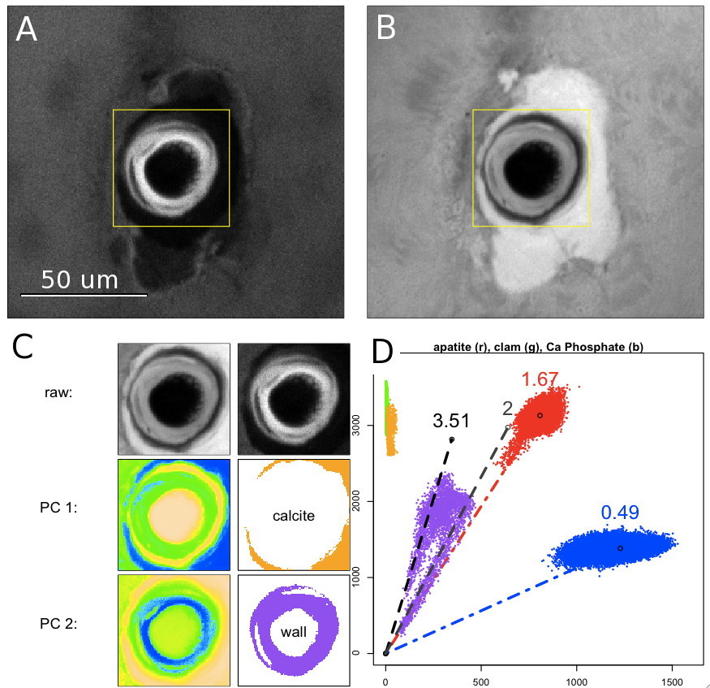

Figure 5. Tangental polished cuticle surface showing organule canal sectioned perpendicular to its long axis illustrating a calcite collar devoid of phosphate and carbonate-apatite lining of the canal. **A.** Phosphorous (Kα) X-ray map. **B.** Calcium (Kα) X-ray map. Note the gap between the canal wall and the **Cal** socket. **C.** rows top to bottom – **raw:** selected areas of Ca, P. **PC 1:** Calcite PC used to choose calcite pixels. **PC 2:** Wall PC used to choose wall pixels. **D.** Calcite and Wall pixels are plotted showing their Ca/P ratios relative to clam calcite (green), HAP (red) and mono-calcium phosphate (blue). A 50 um calibration bar is seen in panel A.







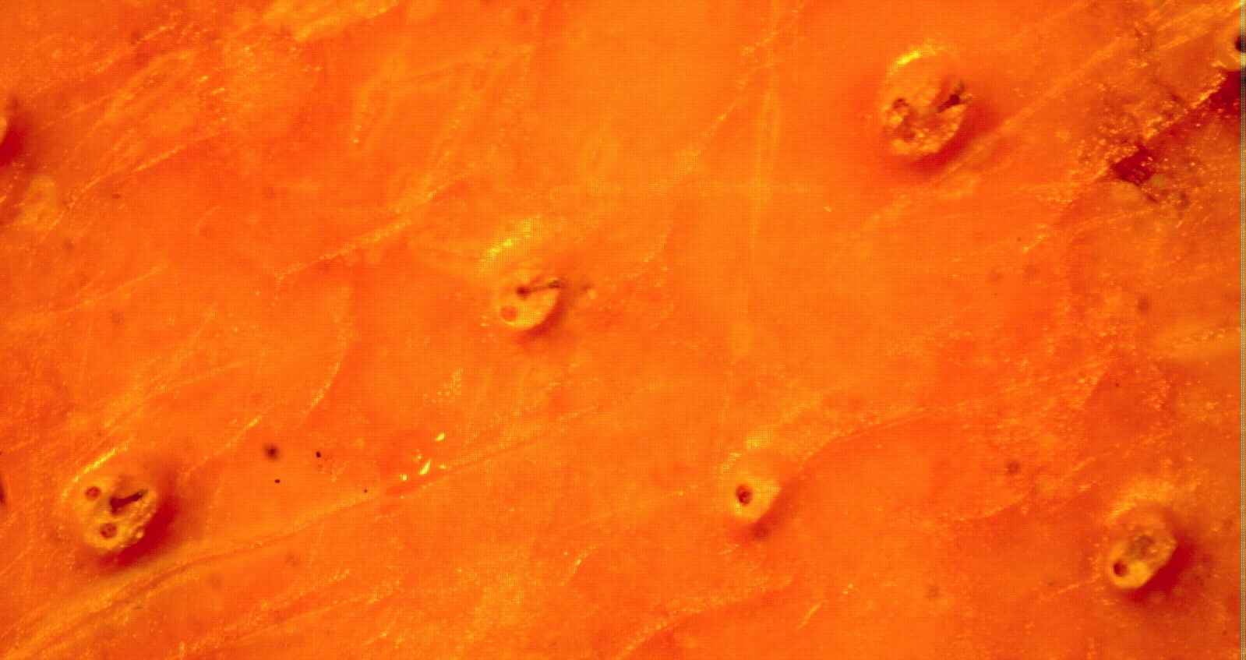

Figure 6. Primary, secondary and tertiary organule cuticle structures on the dorsal carapace of an intermolt lobster. Three size and complexity levels for organules are presented pointed to by increasing sized arrows. The first level is a simple gland tube opening, the second combines a bristle and a gland opening and the third level has more organule components.

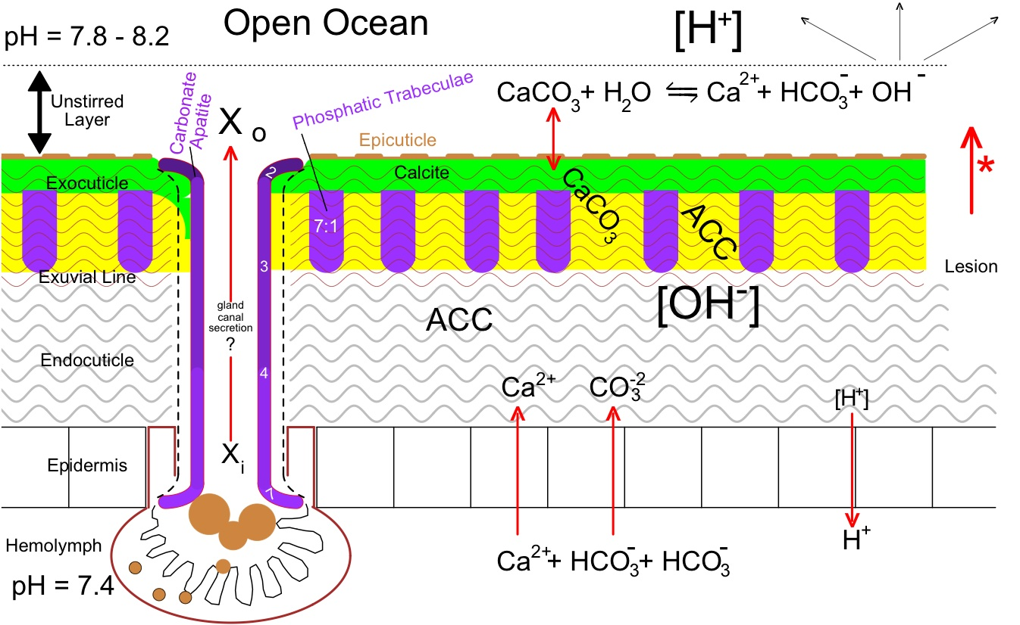

Figure 8. Schematic model of lobster cuticle and basal and apical environment including a dermal gland with graded (2:1 – 7:1 Ca:P) carbonate apatite lined canal secreting a product Xi → Xo. Phosphatic trabeculae are 7:1 Ca:P. During cuticle production Ca2+ and CO3-2 are imported into the cuticle space from the hemolymph side balanced by the expulsion of a proton. At the cuticle outer surface the epicuticle regulates a slow dissolution of the calcite layer that produces a hydroxyl in the unstirred layer when the CO3-2 combines with water. A lesion (asterisk arrow) makes more soluble ACC available for antimicrobial alkalinization.

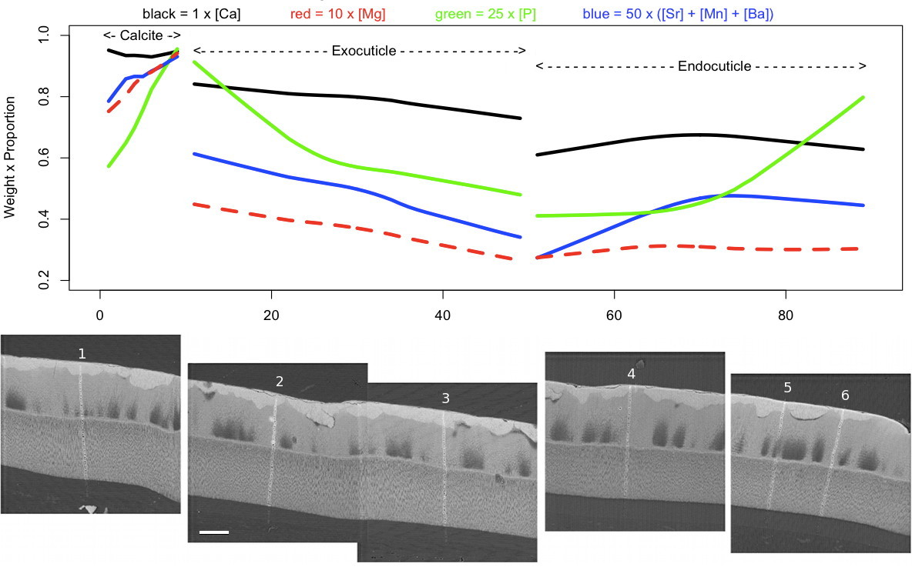

Fig 7. Divalent Cation (Mg, Ca, [Sr+Mn+Ba]) content of the three distinct lobster intermolt cuticle layers: Calcite, Inner-exocuticle, Endocuticle. The average relative molar composition, as measured by EMP backscatter X-ray diffraction, was plotted as sample-wise points from 100 point transects of the approximately 400 um thick cuticles. The paths of the six labeled transects are shown in five electron backscatter images. A hundred micron calibration bar is presented with the image of scan 2.

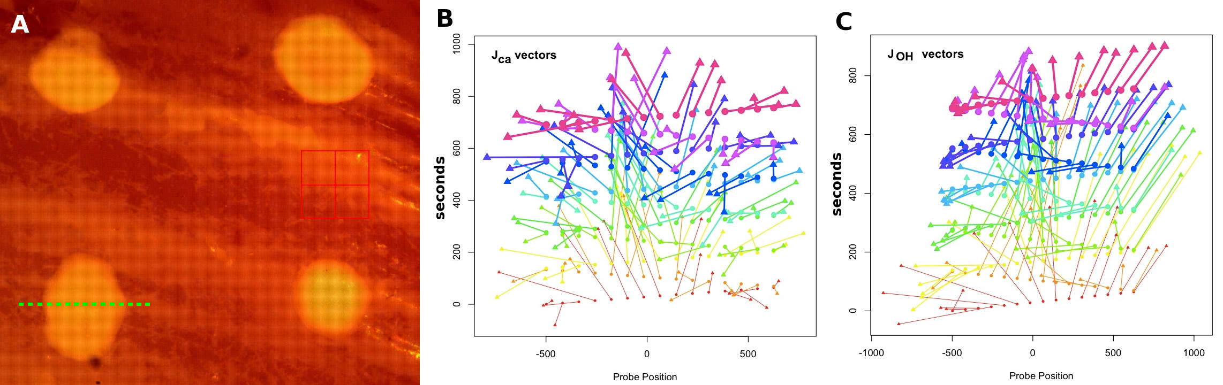

Figure 9. Ca2+ and H+ Flux vectors emanating from an artificial lesion through the periostracal protective layer of a razor clam. **A.** Image of the artificial lesions drilled in the surface of a shell. The dashed green line shows the 1200 um long path of the dual Ca- and H-microelectrodes which were scanned repeatedly across that same path measuring the flux of those tow ions in both the X-direction parallel to the path and the Z-direction perpendicular to the shell surface. These directional fluxes are plotted in panel **B** for the Ca-flux and panel **C** where H-flux is interpreted as the complementary OH-flux. The earliest vectors are depicted thin and become thicker as time progresses. The origin of each vector is a filled circle while the apex of the vector is indicated as a triangle.

Table 1. Calcium Phosphate and Carbonate Apatite Formulae and Ca/P Ratios after Wopenka and Pasteris (2005). In the general formula the proportion of phosphates replaced by carbonates plus hydroxyls varies as well as the number of calciums and balancing hydroxyls to produce a balanced formula. In reality chlorides and fluorides may replace hydroxyls to provide bone with modified properties such as with fluoride-based hardening of bone (Mirtchi et al. 1991).

